22.55: a) Again,  is zero at , by symmetry arguments.

b) 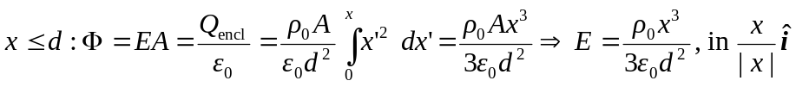direction.
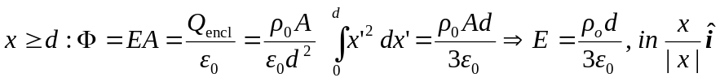direction.

